**2019-2020 Houma Christian Sports Program**

Houma Christian School is currently selling ads for our annual Sports Program.  This years program will include Football, Volleyball, Varsity Cheer, J.V  Cheer, Pep squad and Colorguard, Swim, and Band.  Programs will go on sale the third week of September.  The programs will be completed and distributed the second week of September and sold at all football games.

If you would like to buy an ad, please complete the bottom of this paper and attached your picture or image and return it to school no later than August 30th  .  We welcome both personal and business ads. ADS ARE OPEN TO ALL STUDENTS. Everyone that buys a full page ad will receive one free program.  Everyone who sells $150.00 or greater worth of ads will get 1/8 page free ad. Please write checks out to HCS and title cash envelopes to Booster Program Books. NO FACTS payments are allowed! All money collected will go to athletics to help support all sports teams!

https://ssl.gstatic.com/ui/v1/icons/mail/images/cleardot.gif

DEADLINE is August 30th

Name:__________________________________________Phone:_______________________________

Adress:________________________________City:_______________State:_________Zip:___________

Email:_________________________________________________HCS Student:____________________

Circle One:

1/8 page - $45                    1/4 page - $55                    1/2 page- $80                     3/4 page -$90

                                Full Page - $150                 Inside Back Cover $250                  Outside Back Cover $300

**Every Ad Includes One Picture  **Add $5 for each Additional Picture**

**PAYMENT IS DUE WHEN THIS FORM IS TURNED IN**

Please return form and payment to HCS or mail to:

Houma Christian BOOSTER CLUB 109 Valhi Blvd. Houma, LA 70360

Email : booster@houmachristianschool.com

PLEASE CHOOSE ONE OF THE FOLLOWING OPTIONS:

_____ I would like to design my own ad and will attach it to an email before Aug 30th

_____ I would like to use my business card as an ad (please attach it to this form)

_____ I would like Booster to design my ad -I will email or send picture

_____ I would like Booster to design my ad – use picture from school sport photographer

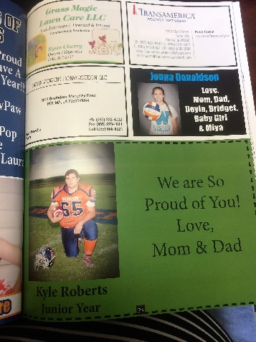 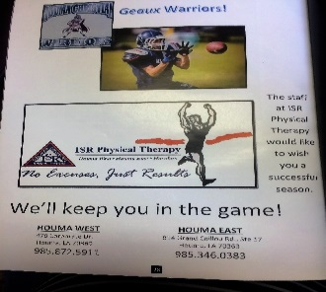

****If you would like to pre-order a sports program you may do so now and send in with your $5 payment.****

____# Books $________ Total Amount Paid

BOOSTER CLUB USE ONLY:

___Cash ____Check Amount Received ________ Check #________Date_______