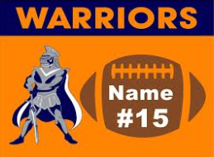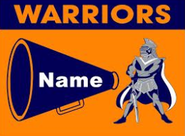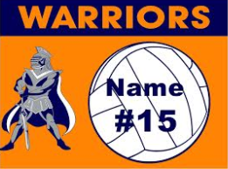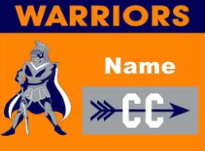
HCS Yard Sign Order Form $20.00 per sign
Signs are Texas orange background with navy and white letters.

Student Name: ________________________________Grade/Home Room:_______________
Name wanted on sign:_________________________________________Qty: ________
Sport choice:__________________________________ Jersey #_____________
Parent Name :____________________________________Phone#:__________________
Please check below how you want us to handle getting the sign to you:
___ send with student
___ call parent to pick up …………………………………………………………………………………………………………………………………………………………………
Number of Signs:______________ Amount Paid: _________________
Check #:________ Cash:_________

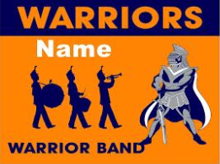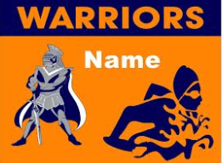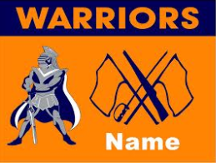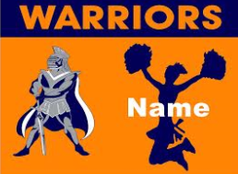
HCS Yard Sign Order Form $20.00 per sign
Signs are Texas orange background with navy and white letters.

Student Name: ________________________________Grade/Home Room:_______________
Name wanted on sign:_________________________________________Qty: ________
Sport choice:__________________________________ Jersey #_____________
Parent Name :____________________________________Phone#:__________________
Please check below how you want us to handle getting the sign to you:
___ send with student
___ call parent to pick up …………………………………………………………………………………………………………………………………………………………………
Number of Signs:______________ Amount Paid: _________________
Check #:________ Cash:________

