Vehicle and Locker Decals
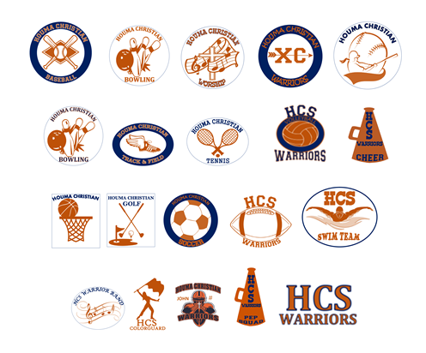

Images in color can be seen on HCS website or Booster Facebook Page

Sports | Student Name /Grade | Qty Of Decals  Qty x $6.00 | # on Decal  Add $1.00 | Name on Decal  $1.00 | Locker Decal  Qty x $6.00 | Total Amount  Due
HCS WARRIORS
Football Opt 1 Football man
Football Opt 2 Football
Volleyball
Cheer
Pep Squad
Guard
Swimming
Band
Cross Country
Golf
Baseball
Softball
Soccer
(Girls & Boys)
Tennis
Bowling
(Girls & Boys)
Basketball
(Girls & Boys)
Worship

Student Name:______________________________________Grade:_______Locker #_______

Total Amount Paid:____________________________ Cash_____ Check______

