HC Lanyards
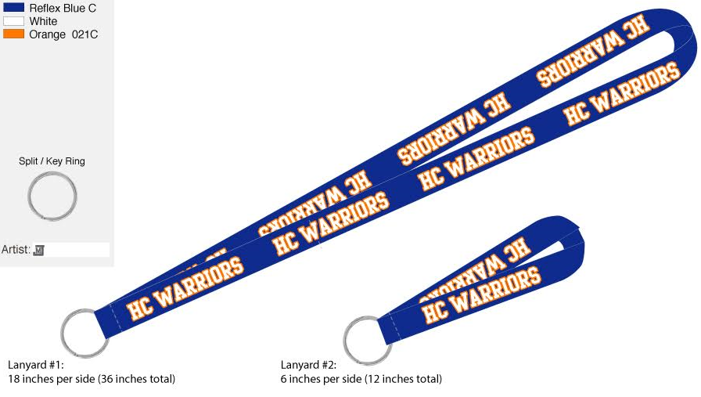
Lanyards are blue with white letters outlined in orange.

Style | Price | Qty. | Total Due
Lanyard #1 (Neck) | $6.00
Lanyard #2 (Wrist) | $5.00

Student Name:______________________________________Grade:_______

Total Amount Paid:____________________________ Cash_____ Check______

HC Lanyards
Lanyards are blue with white letters outlined in orange.

Style | Price | Qty. | Total Due
Lanyard #1 (Neck) | $6.00
Lanyard #2 (Wrist) | $5.00

Student Name:______________________________________Grade:_______

Total Amount Paid:____________________________ Cash_____ Check______

